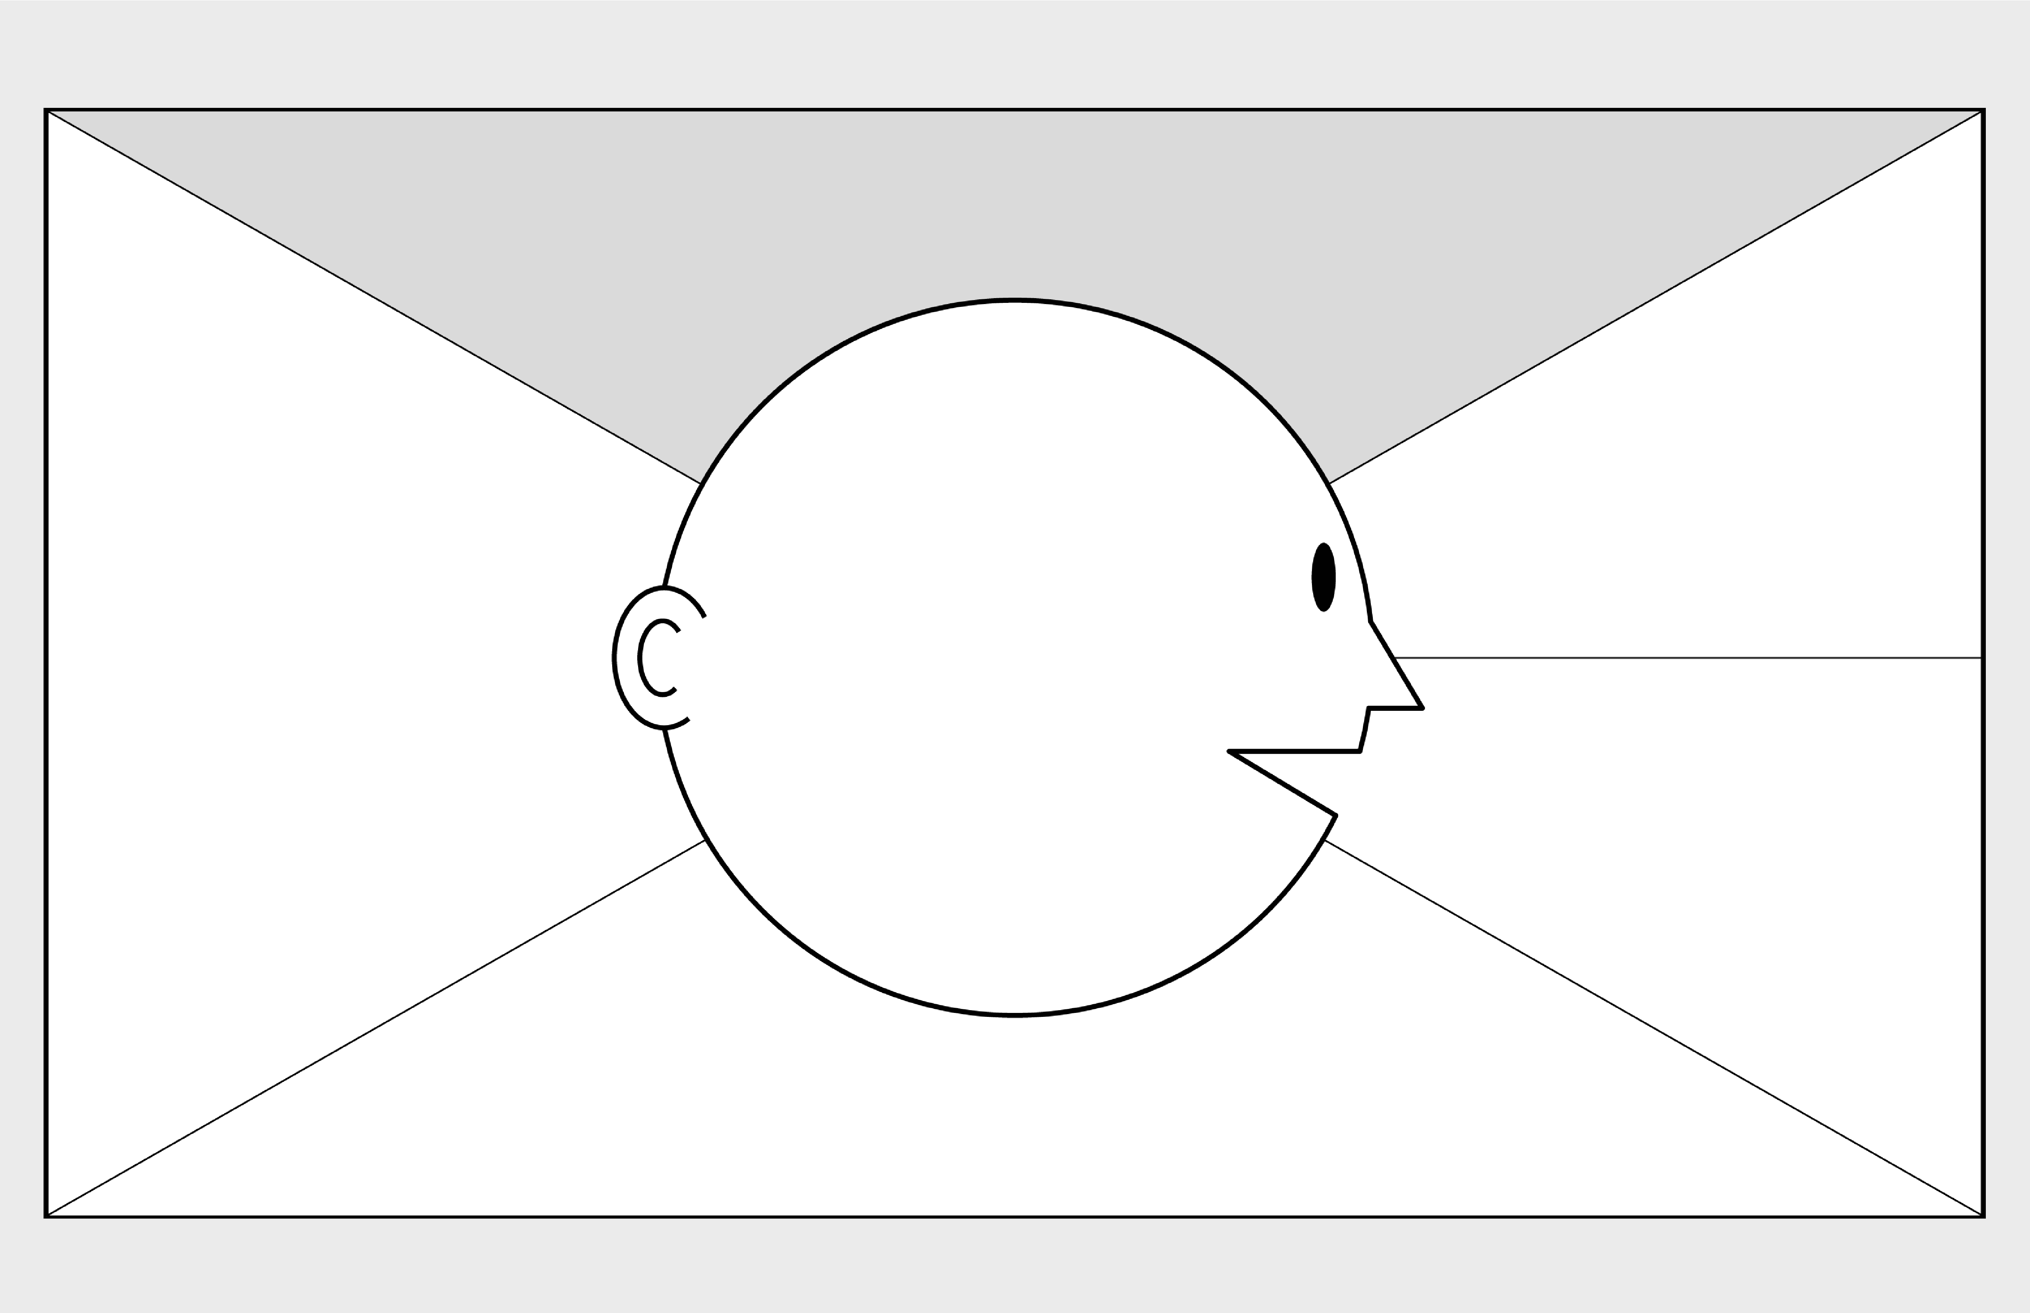

**Empathy Map Canvas**

*Designed for: Relationship manager*

*Designed by Sean CHristian*

*Date:*

*Version:*

**WHO**

**are we empathizing with?**

**Relationship manager**

**What do they need to DO**

**?**

What do they need to do differently? Use a profiler tool to get information regarding about the customer.

What job(s) do they want or need to get done? Successfully make a sale to customers

What decision(s) do they need to make? Which deals is the best for this customer.

How will we know they were successful? More deals are being purchased by customers and customer satisfaction are increased.

Who is the person we want to understand? Relationship managers

What is the situation they are in? RM’s have a lack of information regarding the customer therefore, unable to provide the best matching deals.

What is their role in the situation? Take calls for customers seeking travel deals or information

**GOAL: Improve RM’s work value for calls.**

**What do they**

**SEE?**

**What do they**

**SAY**

**?**

**What do they**

**DO**

**?**

**What do they**

**HEAR**

**?**

**What do they**

**THINK**

**and**

**FEEL**

**?**

What do they see in the marketplace? Competitive prices among other travel agencies.

What do they see in their immediate environment? Customers want to travel by getting the best deals.

What do they see others saying and doing? Travel companies arrange and organised the customer’s travel fully.

What are they watching and reading? Customer reviews and other companies’ prices.

What have we heard them say? Need more information of the customer and more sales.

What can we imagine them saying? More customers are looking to travel.

What do they do today? Receive and take calls from customers and promote deals.

What behavior have we observed? RMs may feel frustrated when are unable to make a sale.

What can we imagine them doing? RMs promoting deals to potential customers based on information gathered.

What are they hearing others say? Which deals are most suitable for customers?

What are they hearing from friends? Their travel experiences are good and would like to be recommended again.

What are they hearing from colleagues? A lot more sales are made.

What are they hearing second-hand?

Where can I get this type of deal?

© 2017 Dave Gray, xplane.com

Last updated on 16 July 2017. Download a copy of this canvas at http://gamestorming.com/empathy

-

map/

**1**

**2**

**3**

**4**

**5**

**6**

**7**

**PAINS**

**GAINS**

What are their fears,

frustrations, and anxieties?

Rude customers

Rejected calls

Unable to make a sale

Not enough information about the customer to get the best deal

Fired

What are their wants,

needs, hopes and dreams?

Make a lot of sales.

Customers are satisfied

Incentives for successful sales.

What other thoughts and feelings might motivate their behavior? Incentives for each successful sales.